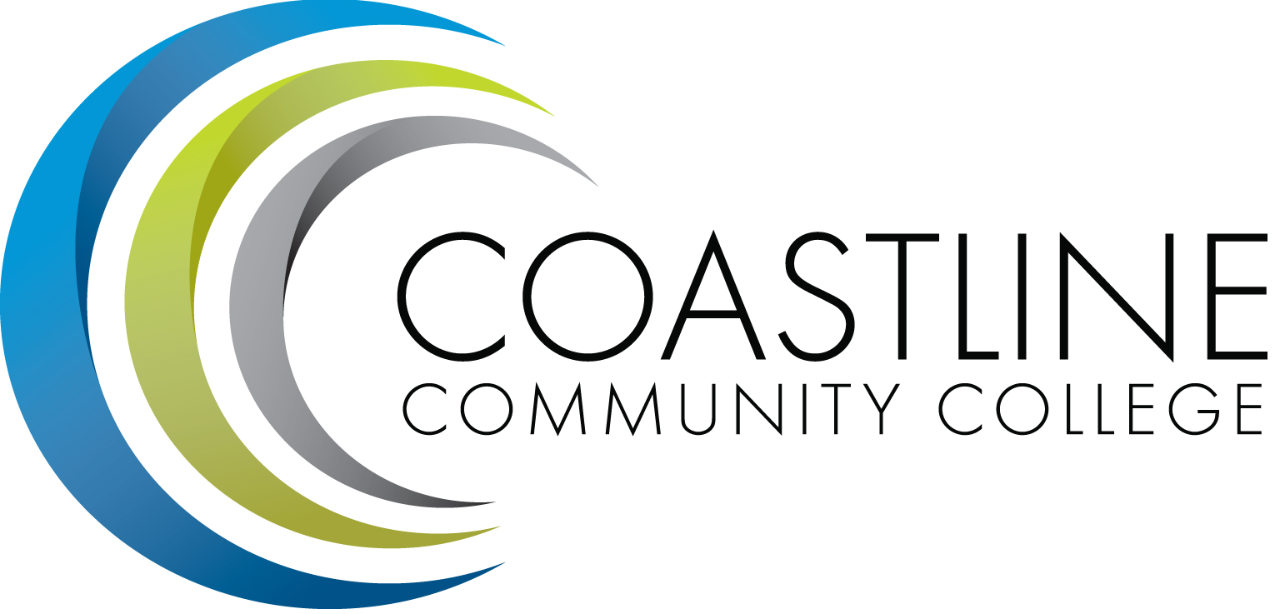

ACADEMIC SENATE
April 3, 2018 12:30 p.m. - 2:30 p.m.
College Center--Fourth Floor Conference Room
AGENDA
College Mission Statement: Coastline Community College steadfastly focuses on providing access and supporting student success and achievement. Inspired by an innovative and student-centered mindset, Coastline delivers flexible courses and services that cultivate and guide diverse student populations across the globe to complete pathways leading to the attainment of associate degrees, certificates, career readiness, and transfer to four-year colleges/universities.

12:30 p.m. 1. CALL TO ORDER: President Stephen Barnes
1.1 Pledge of Allegiance
1.2 Roll Call
1.3 Welcome
1.4 Adopt Agenda
1.5 Approval of Minutes – March 20, 2018**
1.6 Consent Calendar
1.6.1 Approve David Lee to serve as RSI Task Force Faculty co-lead while Dan Johnson is on Sabbatical

1.7 Public Comment and Statement: Members of the public can address the Academic Senators on any item that has been described in this notice, before or during consideration of the item. Persons wishing to make comments are allowed three minutes.

2. SPECIAL PRESENTATION
2.1 Noncredit course and certificate development – Dr. Dana Emerson, Michael Scott
2.2 Single CRN for STAR and Regular Admit Students – Dr. Vince Rodriguez

3. DISCUSSION AND ACTION
3.1 Guided Pathways Coordinator Job Description
3.2 Faculty Success Center Job Description
3.3 Math Requirements for Option 1 Degree

4. DISCUSSION ITEMS
4.1 Senate Executive Committee Nominations
4.2 Senate Subcommittee Policies and Procedures
4.3 Faculty Advising

5. COLLEGE COMMITTEE REPORTS
5.1 PIEAC – Stephen Barnes
5.2 Budget – Rick Lockwood
5.3 Facilities – Michael Warner
5.4 Technology – Cheryl Chapman
5.5 Professional Development & Leadership – Lisa Lee
5.6 Student Success – Ann Holliday
5.7 Curriculum – Deborah Henry
5.8 Accreditation – Danny Pittaway

6. SENATE SUBCOMMITTEE REPORTS
6.1 Academic Rank – Michael Warner
6.2 Academic Standards – Ann Holliday
6.3 Budget – Ann Holliday
6.4 Communications – David Lee
6.5 Elections – Margaret Lovig
6.6 Faculty Recognition – Ann Holliday
6.7 FSC – Rick Lockwood, Cheryl Chapman
6.8 Policy and Procedures – Deborah Henry
6.9 Social – David Lee

7. ANNOUNCEMENTS: (1-minute limit – please sign list to speak)

2:30 p.m. 8. ADJOURNMENT

*Hand-outs available at meeting.
**Copies have been sent to Senators. Others who would like a copy should contact the Senate office at academicsenate@coastline.edu.
Refreshments
Fred Feldon & Christy Nguyen
Contact the Senate Office ~~ We welcome your input!
Stephen Barnes (714) 241-6156 ~~ Email: academicsenate@coastline.edu
Academic Senate Website: http://www.coastline.edu/academicsenate/
Zoom Link: https://zoom.us/j/619853943
NOTES AND NEWS
Stephen Barnes, Academic Senate President
March 20, 2018
- 1st Annual Chicano/Latino Empowerment Summit | Thursday, March 29, 2018; 8:30am – 2pm. Newport Beach Campus. For more information please contact Student Services @ ext. 16218.
- Spring Break | Classes will not meet the week of March 26. Coastline offices and campuses will remain open March 26 – 29. All campuses will be closed on Friday, March 30.
- Academic Senate Luncheon | Tuesday, May 15, 2018. Garden Grove Campus. More information to be announced.
- Intellectual Disabilities (ID) Program Art and Music Night | Friday, May 18, 2018; 5pm – 7:30pm. Newport Beach Campus in the Art Gallery. Music will be outside, on the first floor. Light refreshments will be served. For more information please contact Lisa Winger @ ext. 17216.
- Strawberry Festival Academic Senate Fundraiser | May 25 – 28, 2018; Garden Grove Campus. More information to be announced.
- 2018 Commencement Ceremony | Friday, June 1, 2018; 4pm. Orange Coast College, Robert Moore Theater.

NEXT MEETING
Date: April 3, 2018
Refreshments: Sandra Basabe, Ted Marcus

